English:
Complete this activity and questions at the bottom of the page.
https://theday.co.uk/from-6-7-star-to-accidental-meme-2/
Or, use this QR code to read an article in the news today and answer the questions at the bottom of the webpage.
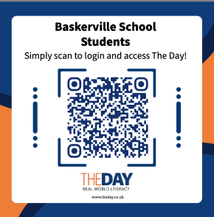

Maths:
Work through the activities in the video in Spring section. Click on Brackets, equations and inequalities and then click on ‘Form algebraic expressions’.
Don’t do the worksheet activities that it refers to. Just complete the video exercises.
https://whiteroseeducation.com/parent-pupil-resources/maths/home-learning?year=year-8

More challenging:
Work through the activities in the video in the Spring section. Click on Maths and money and then click on ‘Solve problems with bills and bank statements’.
Don’t do the worksheet activities that it refers to. Just complete the video exercises.
https://whiteroseeducation.com/parent-pupil-resources/maths/home-learning?year=year-9

