

HR Manager
Baskerville School

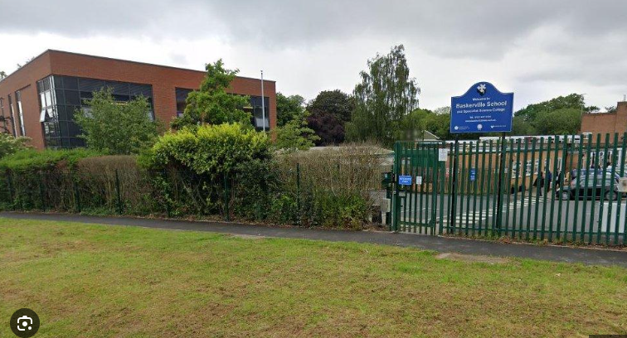

Post Title and Grade | HR Manager  GRADE: Grade 5 - FTE - £42,839 to £51,356 – per annum  Full-time or pro-rata, term-time only, with additional weeks negotiable
Location: | Baskerville School, Fellows Lane, Harborne, Birmingham B17 9TS  Telephone Number 0121 427 3191
Reporting to: | Strategic Business Manager / Headteacher
Direct reports: | HR Assistant
Hours of work: | 36.5 hours per week  08.00am – 16:00pm Mon – Thurs - 08:00am – 15:00 Fridays
Start date: | ASAP
Closing date: | 9th March 2026 at 9:00am
Interview date: | w/c 9th March 2026
About us
Baskerville School
Baskerville School is a specialist secondary school for students with Autism, including students with severe learning difficulties and complex needs, alongside others who successfully complete GCSE courses. Our school is set on a beautiful site with extensive outdoor learning opportunities, supporting our commitment to inclusive, nurturing, and aspirational education.
We are seeking an enthusiastic, highly organised, and dynamic HR professional to join our popular and ambitious school. This is a key role within the school, working closely with the Headteacher and Senior Leadership Team to support, develop, and sustain our most valuable resource — our staff.
We welcome applications from individuals who are passionate about supporting education and who are keen to work in a specialist setting supporting students with Autism. You will be joining us at an exciting time, as the school is in the midst of a major redevelopment, with a brand-new, purpose-built school.

What we can offer:

- A welcoming, experienced, and supportive staff team
- High-quality, purposeful CPD opportunities
- Collaboration and professional opportunities across our six Co-operative Trust Schools
- Forest School provision and outdoor learning opportunities
- Aspirational and supportive Senior and Middle Leadership Teams
- A strong and committed Governing Body
- A positive culture that actively promotes staff wellbeing
Purpose of the role
- To provide a professional, efficient, and comprehensive HR service to the Headteacher and the wider school
- To support the Senior Management Team in workforce planning, staff development, and employee relations

Responsibilities and duties
- Workforce Management
- Manage staffing arrangements, including cover for absences and training
- Liaise with agencies and internal staff to ensure appropriate cover is in place
- Work with the Senior Management Team to develop and monitor the school workforce plan
- Monitor staff turnover, absences, and cover costs
- Recruitment and Staffing
- Lead all recruitment campaigns, including drafting adverts, job descriptions, and person specifications
- Manage DBS checks in line with legal and safeguarding requirements
- Oversee probationary periods for new staff and make recommendations regarding continued employment
- HR Administration and Employee Relations
- Prepare documentation for employee contracts and employment matters for the school and Local Authority
- Manage maternity leave processes and associated risk assessments
- Handle occupational health referrals
- Resolve pay and contract queries
- Communicate and liaise with trade unions regarding employee matters
- Prepare papers and documentation relating to grievance and disciplinary procedures
- Ensure appropriate HR policies are in place and kept up to date
- Training and Development
- Monitor annual performance reviews for all staff
- Develop, implement, and deliver a whole-school training plan
- Work with the Deputy Headteacher to organise on-site training
- Assist in coordinate staff inductions
- Leadership and Reporting
- Provide regular workforce and HR reports, including recruitment, turnover, absence, and staffing data
- Attend and contribute to Senior Management Team meetings
- Support managers and leaders in managing staff effectively
- Provide direct support to the Headteacher as required
General responsibilities and duties
- Undertake other duties as directed by the Headteacher, appropriate to the grade of the post
- Promote and safeguard the welfare of children and young people
- Ensure compliance with Health and Safety requirements
- Engage in appropriate professional development
- Uphold and promote the ethos, vision, and values of the school
- Set a positive example of personal integrity and professionalism
- Attend relevant staff meetings and events
- Support the smooth and effective running of the school

How to Apply
If you feel you have the skills, experience, and commitment to support and inspire staff within a specialist school environment, we would be delighted to hear from you. Please complete the application form, this can be found on our website https://www.baskerville.school/work-for-us

For further information or an informal discussion, please contact: Mandy Singh, HR Manager
📞 0121 427 3191
📧 hr@baskvill.bham.sch.uk

Informal enquiries are warmly welcomed.

Safeguarding Statement
Baskerville School is committed to safeguarding and promoting the welfare of children and young people. The successful candidate will be required to undertake an enhanced Disclosure and Barring Service (DBS) check.

Baskerville School’s Safer Recruitment and Recruitment of Ex-Offenders Policy are available on the school website.

This job description reflects the current requirements of the post. As the school develops and organisational needs change, duties and responsibilities may be reviewed and amended accordingly.

CV’s will not be accepted.
If you do not receive a response to your application 27th February 2026, please assume on this occasion you have not been successful

This school is committed to safeguarding and promoting the welfare of children and expect all staff to share this commitment. The successful candidate will be subject to all necessary pre-employment checks, including: enhanced DBS; Prohibition check; Childcare Disqualification (where applicable); qualifications (where applicable); medical fitness; identity and right to work.

References
All applicants will be required to provide two suitable references

Short-listed candidates
- An online search will also be carried out as part of due diligence on all short-listed candidates

Rehabilitation of Offenders
This post is exempt from the Rehabilitation of Offenders Act 1974 and the amendments to the Exceptions Order 1975, 2013 and 2020. Which means that when applying for certain jobs and activities certain spent convictions and cautions are ‘protected’, so they do not need to be disclosed to employers, and if they are disclosed, employers cannot take them into account. Further information about filtering offences can be found in the DBS filtering guide.

Safeguarding is our top priority. We encourage all applicants to review our Safeguarding and Child Protection Policy, which outlines our commitment to the safety and wellbeing of students.

This post is covered by Part 7 of the Immigration Act (2016).
Therefore, the ability to speak fluent and spoken English is an essential requirement for this role.

